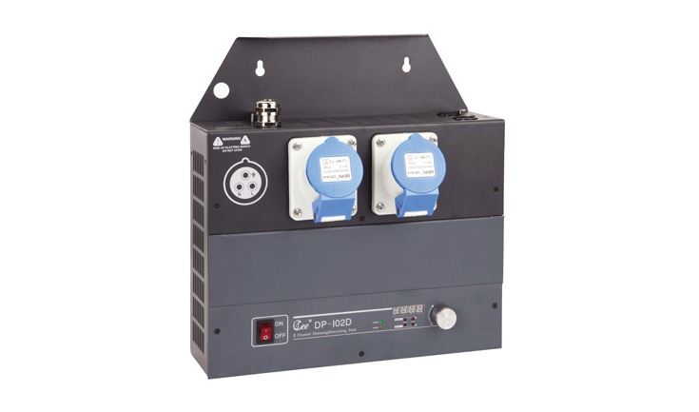

CEE DP-102D

Function and performance:

Two channels 0-100% linear dimming,
Each channel's maximum current is 20A(4KW，220V).
AC220V±10％，50Hz±2％，single-phase three-wire power input.
Standard DMX512(1990) signal control
Each channel has a separate insurance tube with over-current protection function.
Using convection cooling heat,overtemperature protection system, to ensure product sustainable operation.
Select imported high quality silicon controlled rectifier and the maximum isolation voltage is 7500 v.
Using high-performance choke coil suppress harmonic componenteffectively reduces electromagnetic noise.
High precision through zero detection technology,each channel output consistency is good.
Possible being set up manually through the output which can realize emergency output when signal is lost.
Using wall-hung type installation,easy to maintain.
40A standard output socket.

