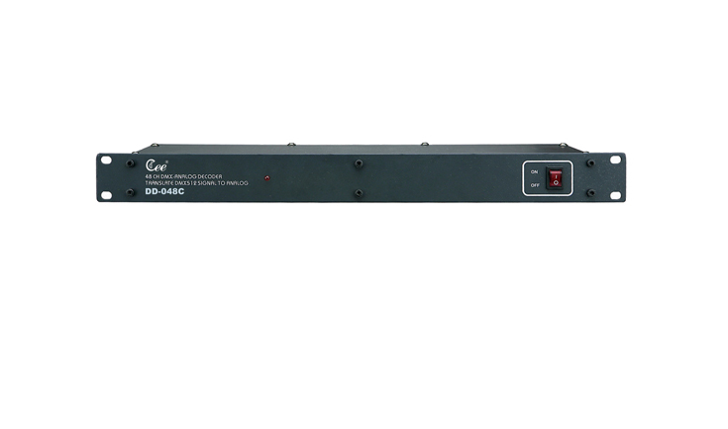

CEE DD-048C

Function and performance
●Convert DMX signal from controller to DC 0-10V analog signal.
●Standard DMX512 input, address code settable.
●48 channels 0-10 volts analogue controlling signal output.
●Power supply: AC100V-240V / 50-60Hz

